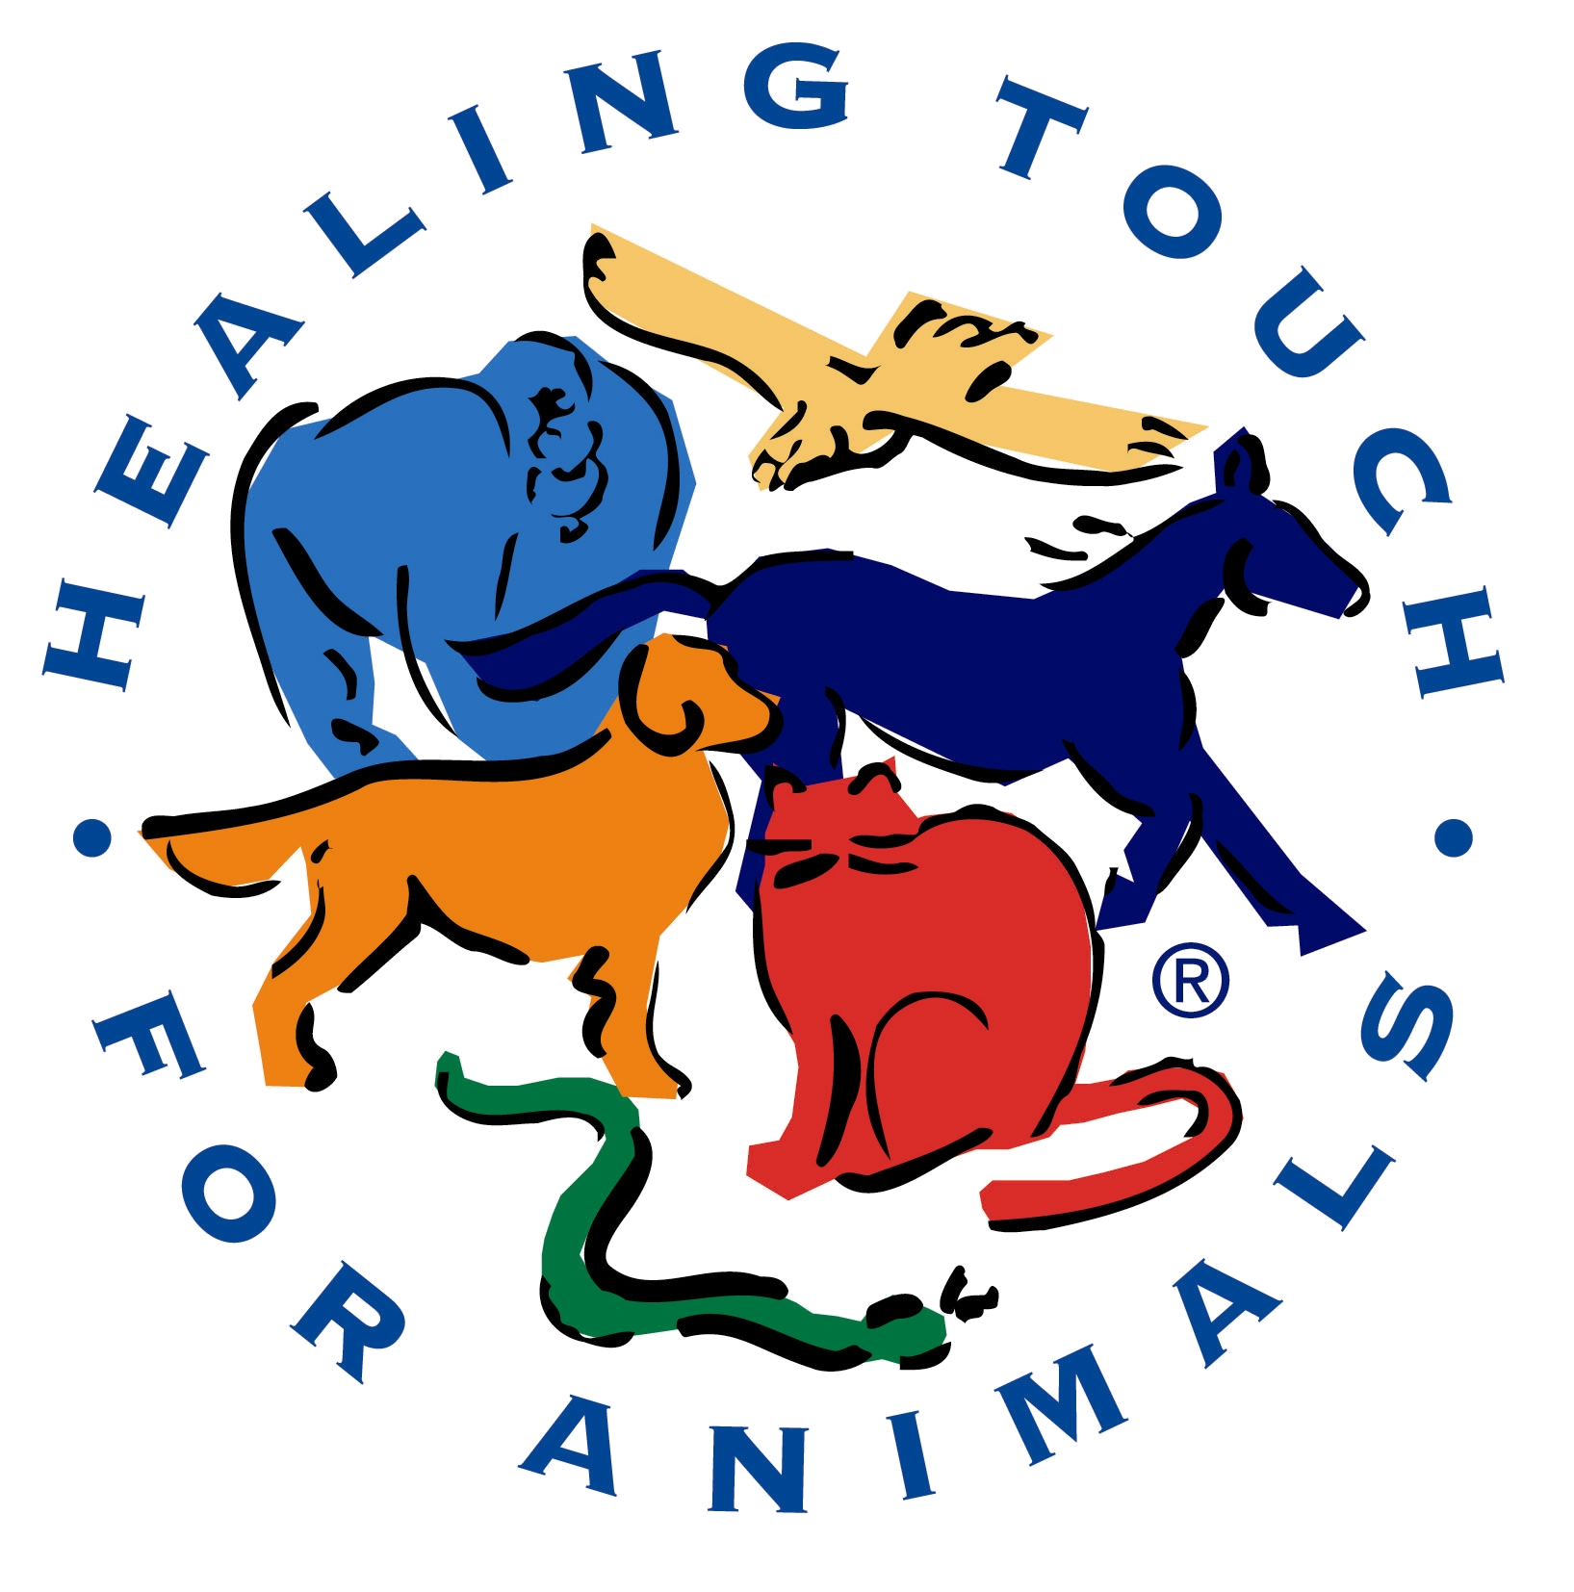
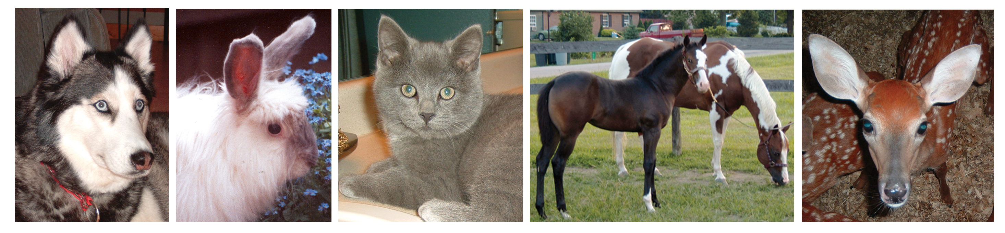

Healing Touch for Animals®

Bridging holistic animal healthcare with traditional veterinary medicine

Healing Touch for Animals® techniques benefit local Veterinary Practices

HTA helps with:

- Health Issues
- Accidents and Injuries
- Pain Control
- Disease Prevention
- Cancer Support
- Behavioral Issues
- Anxiety Reduction
- Euthanasia Process Comfort
- Stabilizes Training
- Ease with Competition Performance
- Better Connection with Our Animals

What some of our HTA Veterinary Professionals say:
“I heard about Healing Touch for Animals® (HTA) about 1 1/2 years ago. At first I was a bit skeptical. Being a veterinarian we learn to be very scientific about things and this was a new way of thinking. But after I completed HTA Level 1, I was excited about the possibilities and about learning more. I have now gone through HTA Level 3 and I am even more excited about using the essential oils. We use HTA in my practice before and after surgeries. I have found that animals awaken more quickly and smoothly using these techniques. My practice also uses the techniques during euthanasia and now with the knowledge of essential oils, we will be using HTA more in everyday practice. The clients we have exposed to it have been very open to it, especially for euthanasia.”

- Dawn L. Bookmyer, DVM Columbus, OH

“Every animal who comes into my hospital receives HTA along with traditional allopathic and holistic veterinary care. Pain and anxiety are drastically reduced by the use of HTA and the precise techniques give tools for specific problems embracing the care and healing of my patients.”

- Jacque McAndrew, DVM, CVCP, CVA San Diego, CA

Register Today for a
Healing Touch for Animals® Course!
HTA, Level 1 comes to Denver January 6 - 8, 2011!

Register online or contact Denver Coordinator:
Coordinator Name XXX-XXX-XXXX or via email at Denver@HealingTouchforAnimals.com

Instructor:
Carol Komitor, CMT, HTCP/I, ESMT, HTACP

www.HealingTouchforAnimals.com

